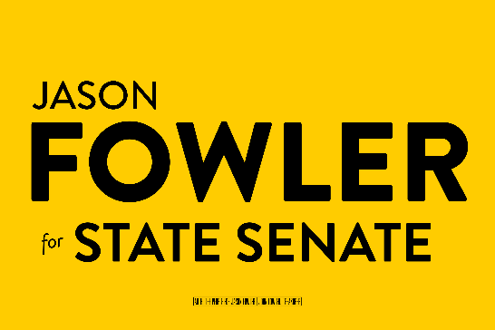

Contact: Len Foxwell
410.202.6694
Len.foxwell@tredavonstrategies.com

SOUTHERN MARYLAND ATTORNEY JASON FOWLER
ANNOUNCES CANDIDACY FOR MARYLAND STATE SENATE
Promises Real Solutions to Maryland’s Affordability, Economic, Fiscal Crises;
“Our Campaign Is About the Families of the 27th District, Not the Annapolis Insiders.”

PRINCE FREDERICK, MD (January 22, 2026) – Promising to be an independent voice for the people of Calvert, Charles and Prince George’s Counties, while delivering pragmatic solutions to Maryland’s most urgent challenges, prominent regional attorney Jason Fowler has announced his candidacy for the 27th District seat in the State Senate.

Speaking before a large crowd of supporters in Prince Frederick on Wednesday evening, Fowler characterized his candidacy as one driven by the desire to build a better state for his children and the next generation.

“Maryland is at an inflection point. The choices we make today, in this moment, will largely determine the lives my children, and yours, can look forward to in the decades to come,” he said. “This campaign will be about speaking to the needs of the 27th District, and offering new ideas that can, and will, help our state achieve its fullest potential.”

Fowler is a practicing family and business lawyer who serves along with his wife and law partner, Tamara, as founding principals of the Prince Frederick firm of Fowler & Fowler Law. He attended Georgetown University Law Center and St. Thomas University, School of Law for his Juris Doctor Degree, and was admitted to practice in the State of Maryland in 2014. The Fowlers live in Huntingtown with their children, Zoey, Zachary and Zara.
Fowler focused much of his announcement speech on the crises of affordability and poverty that has severely compromised Maryland’s quality of life.
“Ours is one of the wealthiest states in the nation, yet nearly 700,000 Marylanders and one in every six children experience hunger on a regular basis,” he said. “Our state is the best place in America to live, work and raise a family, and yet it is also a state that is now priced beyond the reach of families who can no longer afford to stay.”
Fowler pledged specific actions to address the energy affordability crisis, in which ratepayers across the state have seen their electricity costs soar to unprecedented levels. He promised to support the repeal of Senate Bill 1 – the controversial legislation, passed by the Maryland General Assembly in 2024 – that eliminated private sector competition and allowed the public utilities to operate as monopolies within their service territories.
“Anyone with a basic understanding of economics knows that the elimination of competition and the creation of monopolies will inevitably result in higher consumer prices, and Maryland’s electricity markets are no exception,” said Fowler.
He also called for the accelerated development of Maryland’s nuclear and geothermal energy capabilities as a way to reduce our dependence on out-of-state and fossil fuel-generated electricity.
“These emerging energy sources are renewable and they are ours,” said Fowler. “We must do a better job of investing in our local sources of clean power.”
Pointing out that Maryland lawmakers will confront a $1.5 billion budget deficit even as neighboring states such as Virginia boast multibillion surpluses, Fowler called for a new fiscal and economic approach for the state.
“There are those who believe that the measure of one’s commitment to an issue can only be measured by how much they are willing to spend toward its implementation. That, respectfully, is nonsense,” said Fowler. “We can and must demand better results from those institutions we sustain through our tax dollars. We must manage taxpayer dollars as carefully as we would manage our own.
“Above all, we must acknowledge that we can no longer count upon the federal government as our fiscal and economic backstop,” he added, noting that Maryland lost 25,000 federal jobs in 2025 because of President Trump’s cuts to the federal government. “We must act now to build a more stable, predictable and welcoming environment for our private sector, so Maryland businesses can create jobs, generate tax revenue and support one another.”

Finally, Fowler acknowledged the challenges that Maryland has faced at a time when the Trump Administration is violating core constitutional principles and basic human rights. He vowed to use his Senate seat to defend Maryland’s values.
“I will fight like hell to safeguard those programs that provide food for the hungry, shelter for the homeless, and education for children in my district, regardless of what is on their birth certificate,” he said. “This is the United States of America, whether Donald Trump and his acolytes like it or not, and these are basic necessities that every human being deserves.”

Maryland’s primary election day is June 23, 2026. Fowler said that time of the essence and asked each of his supporters to take an active role in his candidacy.

Each of us, doing our part, can leave our children a state that will be better tomorrow than it is today,” he said. “It is in the pursuit of that dream that I begin this good fight and humbly ask that you join me in the arena.”

